Asymmetric DCC correlation: GBPUSD and AUDUSD
Method 10 / GARCH(1,1) + Cappiello-Engle-Sheppard ADCC / Alpari D1 full available history

Study setup
Logical pair: GBPUSD , AUDUSD
Broker symbols: GBPUSD_i , AUDUSD_i
Snapshot: 2026-11-03_majors_alpari_D1
Timeframe: D1
Matched return window: 1999-01-05 to 2026-11-02 (UTC bar dates)
Matched return count n: 7228
Dropped unfinished last bar dated 2026-11-03 UTC after a tick-volume check against the prior complete day.
GBPUSD GARCH(1,1): mu=0.000017, omega=0.004039, alpha=0.055362, beta=0.932177
AUDUSD GARCH(1,1): mu=0.000026, omega=0.005405, alpha=0.052119, beta=0.937285
ADCC: a=0.017183, b=0.980953, g=0.000000, a+b+g/2=0.998137
Nested DCC (g=0): a=0.017183, b=0.980953
Negative shock: n = min(z, 0) in broker quote direction (not inverted)
Burn-in ignored in path summaries and chart: first 60 updates
Complete matched rows (Excel): GBPUSD-AUDUSD_ADCC_D1.xlsx
Complete matched rows (HTML table): GBPUSD-AUDUSD_ADCC_D1_data.html

Method carried forward
Asymmetric DCC extends Engle DCC with an extra term on joint negative standardised shocks. Each matched daily log return of close, ln(close_t / close_t-1), is first filtered by a constant-mean GARCH(1,1). Then z = residual / sigma and n = min(z, 0). The Cappiello-Engle-Sheppard recursion uses A = (1-a-b) Q_bar - g N_bar with N_bar = mean(n n'). Quotes are not inverted, so a negative shock is a negative log return in the broker quote. Nested symmetric DCC (g = 0) is fit on the same z path for comparison. Constraints: a,b,g >= 0 and a + b + g/2 < 1. Path summaries ignore the first 60 updates. The headline is latest ADCC rho. Pearson r is a side check only. This is not a cause, lead, or trading signal.

Results
Latest ADCC rho: 0.504442
Latest nested DCC rho: 0.504442
Post-burn-in ADCC path (n=7168): mean=0.513203, median=0.538073, min=0.003502, max=0.787392, std=0.165140
Share of post-burn-in days with |rho| >= 0.4: 73.42%; |rho| >= 0.7: 10.59%
Same-sample Pearson r: 0.539048
ADCC minus r: -0.034606
ADCC minus nested DCC: 0.000000

Conclusion
Over 7228 matched daily log-return rows for GBPUSD and AUDUSD (broker quote directions unchanged), latest ADCC rho is 0.5044 (positive, moderate conditional linear link in this sample) with fitted a=0.0172, b=0.9810, g=0.0000. Nested symmetric DCC latest rho is 0.5044 (ADCC minus DCC = 0.0000). After a 60-day burn-in, path mean is 0.5132 and std is 0.1651. Same-sample Pearson r is 0.5390 (ADCC minus r = -0.0346). This does not establish cause, lead-lag, or a lasting trading rule.

Charts
Daily closes

Daily log returns
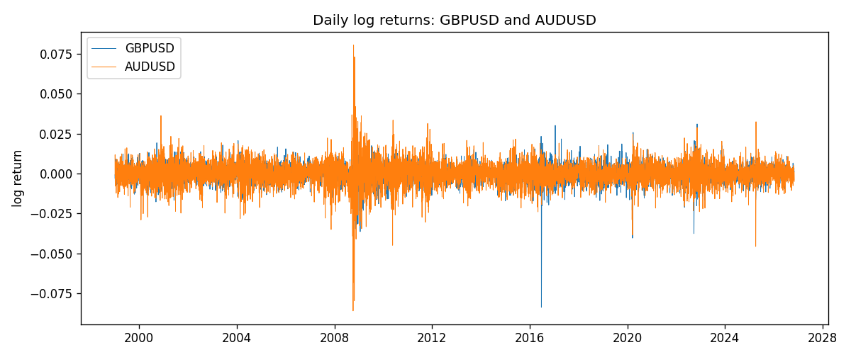
ADCC rho path with nested DCC and Pearson r
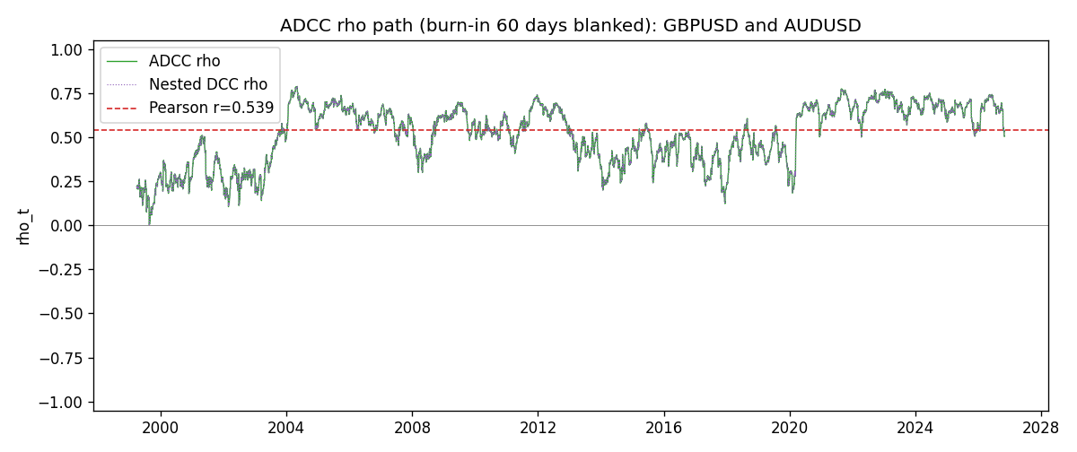

Data report
Every matched row that entered the ADCC recursion is stored in the sibling Excel workbook named GBPUSD-AUDUSD_ADCC_D1.xlsx. Embedding all rows as a Word table is impractical at this length; the Word file holds the column list, column summaries, and the first and last 15 matched rows.
Columns: time, GBPUSD_open, AUDUSD_open, GBPUSD_high, AUDUSD_high, GBPUSD_low, AUDUSD_low, GBPUSD_close, AUDUSD_close, GBPUSD_tick_volume, AUDUSD_tick_volume, GBPUSD_spread, AUDUSD_spread, GBPUSD_real_volume, AUDUSD_real_volume, GBPUSD_log_return, AUDUSD_log_return, GBPUSD_sigma, AUDUSD_sigma, GBPUSD_z, AUDUSD_z, GBPUSD_n, AUDUSD_n, q11, q22, q12, rho_adcc, rho_dcc
Column summaries (matched calculation rows)
column | count | mean | std | min | 25% | 50% | 75% | max
GBPUSD_open | 7228 | 1.5166822 | 0.21834818 | 1.06854 | 1.3254025 | 1.51196 | 1.63237 | 2.1066
AUDUSD_open | 7228 | 0.75192541 | 0.13534725 | 0.4785 | 0.66102 | 0.7315 | 0.8091975 | 1.10284
GBPUSD_high | 7228 | 1.5229801 | 0.21891417 | 1.08366 | 1.3300275 | 1.518725 | 1.638825 | 2.1161
AUDUSD_high | 7228 | 0.75597511 | 0.13590934 | 0.4878 | 0.664695 | 0.734945 | 0.81552 | 1.10795
GBPUSD_low | 7228 | 1.5103473 | 0.21757706 | 1.03518 | 1.32009 | 1.50469 | 1.624985 | 2.0983
AUDUSD_low | 7228 | 0.74786335 | 0.13465689 | 0.4775 | 0.6577 | 0.72762 | 0.804475 | 1.0975
GBPUSD_close | 7228 | 1.5167386 | 0.2183035 | 1.06879 | 1.32568 | 1.51203 | 1.6324775 | 2.1065
AUDUSD_close | 7228 | 0.75196864 | 0.13532707 | 0.4786 | 0.6611875 | 0.731775 | 0.809315 | 1.10169
GBPUSD_tick_volume | 7228 | 94565.268 | 153330.81 | 62 | 9974.5 | 52775.5 | 91622.5 | 1273370
AUDUSD_tick_volume | 7228 | 77126.179 | 137934.11 | 109 | 5406 | 43250.5 | 71246.75 | 1234623
GBPUSD_spread | 7228 | 27.003182 | 19.183813 | 0 | 11 | 20 | 50 | 50
AUDUSD_spread | 7228 | 30.855562 | 16.875394 | 0 | 13 | 30 | 50 | 50
GBPUSD_real_volume | 7228 | 3.5428062e+09 | 8.4280615e+10 | 0 | 0 | 0 | 0 | 2.4038164e+12
AUDUSD_real_volume | 7228 | 5.2225089e+09 | 1.2514647e+11 | 0 | 0 | 0 | 0 | 3.811512e+12
GBPUSD_log_return | 7228 | -2.954e-05 | 0.0056473 | -0.08388241 | -0.00313242 | 3.002e-05 | 0.00317333 | 0.03112653
AUDUSD_log_return | 7228 | 1.629e-05 | 0.00754363 | -0.08602525 | -0.00386494 | 0.00027649 | 0.00415111 | 0.0806166
GBPUSD_sigma | 7228 | 0.00539544 | 0.0016979 | 0.00300649 | 0.00447815 | 0.00503733 | 0.00577328 | 0.02198775
AUDUSD_sigma | 7228 | 0.00694206 | 0.00278483 | 0.00391282 | 0.00551915 | 0.00627033 | 0.00759406 | 0.03848611
GBPUSD_z | 7228 | -0.00705533 | 1.0000203 | -10.311384 | -0.60009235 | 0.00257884 | 0.60716216 | 4.9477396
AUDUSD_z | 7228 | -0.00469142 | 1.0001095 | -8.472305 | -0.60543351 | 0.04067797 | 0.63842203 | 5.0260311
GBPUSD_n | 7228 | -0.38656838 | 0.60980036 | -10.311384 | -0.60009235 | 0 | 0 | 0
AUDUSD_n | 7228 | -0.38824156 | 0.62428159 | -8.472305 | -0.60543351 | 0 | 0 | 0
q11 | 7228 | 1.0017467 | 0.17799395 | 0.57208579 | 0.90970692 | 0.98492955 | 1.0612065 | 3.1110819
q22 | 7228 | 1.0019015 | 0.16967693 | 0.65120267 | 0.89701293 | 0.97783903 | 1.0745366 | 2.2448651
q12 | 7228 | 0.51351808 | 0.19230413 | 0.0035857 | 0.37713061 | 0.52796582 | 0.63838834 | 1.1674529
rho_adcc | 7228 | 0.5110589 | 0.16635483 | 0.00350223 | 0.38775252 | 0.53565814 | 0.65553054 | 0.78739206
rho_dcc | 7228 | 0.5110589 | 0.16635483 | 0.00350213 | 0.38775252 | 0.53565815 | 0.65553053 | 0.78739208
First 15 matched rows (selected columns)
time | GBPUSD_log_return | AUDUSD_log_return | GBPUSD_z | AUDUSD_z | GBPUSD_n | AUDUSD_n | q11 | q22 | q12 | rho_adcc | rho_dcc
1999-01-05 | -0.0028966287 | -0.00080418179 | -0.71456228 | -0.13255951 | -0.71456228 | -0.13255951 | 1 | 1 | 0.51244324 | 0.51244324 | 0.51244324
1999-01-06 | -0.00060452184 | 0.011836351 | -0.15355382 | 1.9323736 | -0.15355382 | 0 | 0.99159039 | 0.98311846 | 0.50526533 | 0.51174124 | 0.51174124
1999-01-07 | -0.002118709 | 0.0088650256 | -0.53920418 | 1.3507274 | -0.53920418 | 0 | 0.97497224 | 1.0304208 | 0.49149774 | 0.49036344 | 0.49036343
1999-01-08 | -0.0058954193 | 0.00031515916 | -1.5125988 | 0.04320085 | -1.5125988 | 0 | 0.9632614 | 1.0440086 | 0.47057608 | 0.46925157 | 0.46925155
1999-01-11 | -0.0056851331 | 0.0072213815 | -1.400308 | 1.1038729 | -1.400308 | 0 | 0.98609273 | 1.0260189 | 0.46144509 | 0.45875781 | 0.45875778
1999-01-12 | 0.0022657001 | -0.0048608485 | 0.53516969 | -0.74473975 | 0 | -0.74473975 | 1.0028686 | 1.0292785 | 0.4270493 | 0.42032918 | 0.42032914
1999-01-13 | 0.0091330396 | -0.0078902098 | 2.2016093 | -1.2194176 | 0 | -1.2194176 | 0.99055194 | 1.021068 | 0.41302154 | 0.41068302 | 0.41068298
1999-01-14 | 0.0019376331 | -0.002696916 | 0.41929427 | -0.41378359 | 0 | -0.41378359 | 1.0568382 | 1.0290347 | 0.35997747 | 0.34518829 | 0.34518821
1999-01-15 | -0.0017558204 | 0.007123101 | -0.39465932 | 1.1013952 | -0.39465932 | 0 | 1.0415931 | 1.0142403 | 0.35109463 | 0.34158965 | 0.34158958
1999-01-18 | 0.0012112405 | 0.00094592471 | 0.27132003 | 0.14178358 | 0 | 0 | 1.0262938 | 1.0176304 | 0.33789302 | 0.33063462 | 0.33063454
1999-01-19 | 0.0018745281 | 0.0072225153 | 0.43133551 | 1.1374603 | 0 | 0 | 1.0098745 | 1.0004565 | 0.33307313 | 0.33136512 | 0.33136504
1999-01-20 | -0.0049053846 | 0.0012507819 | -1.1637993 | 0.19182313 | -1.1637993 | 0 | 0.99569989 | 1.0054966 | 0.3361147 | 0.33591777 | 0.3359177
1999-01-21 | 0.0031518998 | 0.00078094498 | 0.7304984 | 0.1211421 | 0 | 0 | 1.0018721 | 0.98884068 | 0.32683156 | 0.32836335 | 0.32836327
1999-01-22 | 0.0024781662 | -0.012252745 | 0.57826354 | -2.019885 | 0 | -2.019885 | 0.99382256 | 0.97212191 | 0.32308197 | 0.32869865 | 0.32869858
1999-01-25 | 0.0012066366 | -0.0039591468 | 0.28339626 | -0.60750472 | 0 | -0.60750472 | 0.98250269 | 1.025577 | 0.2978124 | 0.29668239 | 0.29668231
Last 15 matched rows (selected columns)
time | GBPUSD_log_return | AUDUSD_log_return | GBPUSD_z | AUDUSD_z | GBPUSD_n | AUDUSD_n | q11 | q22 | q12 | rho_adcc | rho_dcc
2026-10-13 | 0.0036434319 | 0.0035007712 | 0.98774155 | 0.76905043 | 0 | 0 | 0.76009095 | 0.7634604 | 0.49732553 | 0.65285196 | 0.65285194
2026-10-14 | -0.0049164679 | -0.0015193215 | -1.3328573 | -0.34300125 | -1.3328573 | -0.34300125 | 0.76424178 | 0.76094525 | 0.50186088 | 0.65809903 | 0.65809901
2026-10-15 | 0.0065976411 | -0.0075447063 | 1.7269614 | -1.7060045 | 0 | -1.7060045 | 0.78207539 | 0.75033666 | 0.50111269 | 0.65415853 | 0.65415851
2026-10-16 | 0.0037592051 | 0.0033906408 | 0.92588725 | 0.71752401 | 0 | 0 | 0.82029066 | 0.78792022 | 0.44189688 | 0.54966227 | 0.54966219
2026-10-19 | -0.0017500314 | 0.0050859986 | -0.43615194 | 1.0852335 | -0.43615194 | 0 | 0.82126092 | 0.78362296 | 0.44585079 | 0.55577036 | 0.5557703
2026-10-20 | 0.0055923442 | 0.0034620426 | 1.3994618 | 0.72840649 | 0 | 0 | 0.81075066 | 0.79079833 | 0.43018021 | 0.53724687 | 0.53724679
2026-10-21 | 0.0012476328 | 0.0036066384 | 0.2992255 | 0.76318171 | 0 | 0 | 0.83082553 | 0.78671664 | 0.44045795 | 0.5448041 | 0.54480403
2026-10-22 | 0.00022396082 | -0.0012672558 | 0.051385224 | -0.27677797 | 0 | -0.27677797 | 0.81840284 | 0.78360401 | 0.43694757 | 0.54562899 | 0.54562893
2026-10-23 | -0.0021146949 | 0.0023765656 | -0.54025335 | 0.51172323 | -0.54025335 | 0 | 0.80472359 | 0.77185856 | 0.42933558 | 0.5447593 | 0.54475923
2026-10-26 | -0.0024340661 | -0.0032032829 | -0.62934743 | -0.71150181 | -0.62934743 | -0.71150181 | 0.79627493 | 0.76352015 | 0.41736241 | 0.53526834 | 0.53526827
2026-10-27 | -0.0023648393 | 0.0016669876 | -0.61754583 | 0.36333715 | -0.61754583 | 0 | 0.78977779 | 0.75953976 | 0.4180623 | 0.53977566 | 0.53977559
2026-10-28 | 0.0015771808 | 0.0040915541 | 0.40863528 | 0.91372628 | 0 | 0 | 0.78315154 | 0.74920476 | 0.40719882 | 0.53159801 | 0.53159794
2026-10-29 | 0.0035881935 | -0.0040915541 | 0.95004665 | -0.92176436 | 0 | -0.92176436 | 0.7729677 | 0.75114458 | 0.40681383 | 0.53389182 | 0.53389175
2026-10-30 | 0.0013450605 | 0.0010102376 | 0.35146645 | 0.2193389 | 0 | 0 | 0.7756181 | 0.75330097 | 0.38497227 | 0.50364116 | 0.50364108
2026-11-02 | 0.0010971256 | -0.0049184984 | 0.29065609 | -1.1209748 | 0 | -1.1209748 | 0.76483105 | 0.74164304 | 0.37991932 | 0.50444191 | 0.50444183

